ORTHODOX SYRIAN SUNDAY SCHOOL
ASSOCIATION OF THE EAST
DIOCESE OF SOUTH WEST AMERICA

Teachers Training Certification
Model Examination Question Paper

Reg. No.:

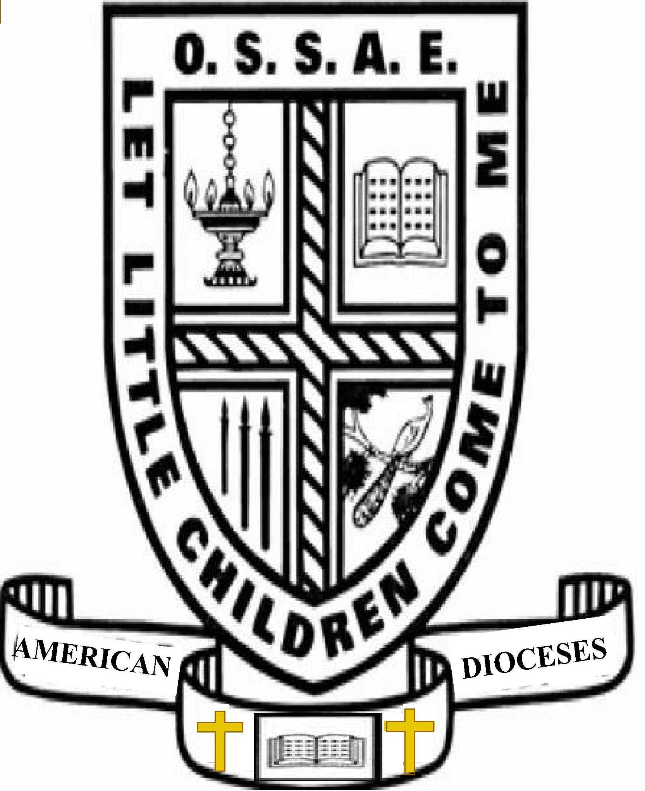

Examination Rules

Examination Rules

- Total time limit for this examination is two hours.
- Do not write your name anywhere on exam booklet.
- Return the entire exam booklet upon completion.
- Teachers may answer in Malayalam.
- Teachers may not leave exam hall until 60 minutes have expired.
- Please use only black or blue ink. Pencils are NOT allowed.
- If needed, please use the separate answer sheets provided, separate answer sheets must have student registration number filled out.
- No electronics devices (includes cell phones, iPods, etc)
- Teachers are encouraged to use the Orthodox Study Bible or an NSRV translation of The Holy Bible. Only paper-copies are allowed, and Bibles may only be the OSB or NSRV.
Teachers Training Certification (TTC)
Model Question Paper - 2012

Time: 2 hours Total points: 100
Note: This examination is an assessment of the Teacher’s knowledge and understanding of the Orthodox Faith, and ability to apply with respect to teaching the Faith to others. Questions are based on the materials available at the Diocese website (http://ds-wa.org/sunday-school-teachers-certification-program.html), Teachers Notes, the Orthodox Study Bible and the prayers and hymns of the Holy Qurbana.

PART 1: Fill-in-the-blank (10 points)
- As recorded in the (Acts of the Apostles), the first Council in the life of the Christian church took place in Jerusalem
- At the Council of Ephesus, the heretic (Nestorius) claimed that Jesus Christ was born a human and later became a God
- The (Oriental) Orthodox Churches include the Syriac, Coptic, Armenian, Ethiopian, Eritrean, and Malankara Orthodox Churches.
- St. (Athanasius) refused to accept a compromise that ‘Jesus is of similar substance to the Father’, insisting that ‘Jesus is of the same substance as the Father’
- T he Septuagint was the Holy Scripture prepared in the (Greek) language during the reign of King Ptolemy II (285 - 247 B.C.), and was the Scripture used by the early Christian Church.
- The 5 books of the (Law) (Pentateuch) comprise of Genesis, Exodus, Leviticus, Numbers, and Deuteronomy.
- The Sacrament of (Baptism) is our death, burial, and resurrection in union with Jesus Christ. It is a rite of passage, given by Christ to the Church as an entrance into the Kingdom of God and eternal life.
- (Sacraments) are mysteries which impart God’s grace and help us to grow spiritually in Church as the Body of Christ.
- The official name of the Indian Orthodox Church is “the (Malankara) Orthodox Syrian Church”
- The (Filioque) Clause is the addition to the Nicene Creed by the Roman Catholic Church that proclaims the Holy Spirit proceeds from the Father and the Son.

PART 2: In a few sentences, explain your understanding of the following terms. Please note that these are defined in the Orthodox Study Bible, and the expectation is for you to explain in your own words (15 points)
- Free Will
- Typology
- Parable
- Deification (or Theosis)
- Trisagion

PART 3: True/False (10 points)
1. | The Oriental Orthodox Church believes that Jesus Christ Jesus has two nature, which is partially divine and partially human | T/F
2. | The New Testament has 27 Books | T/F
3. | St. Mary was born without Sin | T/F
4. | As we read in the Gospel of John, the Holy Qurbana symbolizes the Body and Blood of our Lord Jesus Christ | T/F
5. | The Orthodox Church maintains that the Holy Bible is the sole authority and foundation of Christian Faith | T/F
6. | The Nicene Creed was completed at the Council of Constantinople in 381 A.D. | T/F
7. | The Serbian Orthodox Church is not a member of the Oriental Orthodox family of Churches | T/F
8. | Jehovah’s Witnesses believe that Christ was created by God and the Holy Spirit was created by Christ | T/F
9. | Orthodox Christians believe that Christ was crucified as a vehicle to appease God’s wrath over the sin of Adam and Eve | T/F
10. | In the Nicene Creed, we profess that God created Heaven, Hell and Earth | T/F

PART 4: Short Answers (30 points)
- Church tradition follows what St. Paul said, “For I received from the Lord what I also handed on to you” (e.g., 1 Corinthians 11:23). Explain what the Apostle Paul was teaching.
- What is our hope about the faithful departed? Why do we do prayers for the departed?
- What was the teaching of Arius? Why was Arianism dangerous for Christianity?
- The Protestant Bible has only 66 Books in the Old Testament. Why?
- Can a true Christian claim to love Jesus Christ and hate the Church? (Hint: Ephesians 1:23)
- What is the Church teaching of the fall of mankind and God’s love towards humanity?

PART 5: Apologetics Essay (20 points)
Choose any two (2) of the following topics:
- Infant Baptism
- Holy Eucharist
- Holy Spirit
- St. Mary the Theotokos (Mother of God)

Structure your answer so that the following points are brought out:
- Describe views that are held by many outside of our Church that differ from the teachings. Provide your own examples or experiences to communicate the misunderstandings
- Explain how you would clarify to a person who held that view on the proper Orthodox understanding of the departed.
- Extra credit will be given to those who support their points with Scripture, Liturgical prayers or hymns, actions at the Holy Qurbana or other sources from the Church.

PART 6: Using the Scriptural verses given (as well as any other relevant verses that you can remember), explain the teaching contained in the following Liturgical Hymns and Prayers (25 points)

 | Scripture Verse | Holy Qurbana Hymn, Prayer or action
1. | Isaiah 6 | Seraphim of fiery line (Srappikale kandeshaya........)
2. | Galatians 1:5-9 | Paul the Blessed (Paulose sleeha dhanya-nchol …)
3. | John 15:26 | Nicene Creed - “And in the One living Holy Spirit, … who proceeds from the Father and who with the Father and Son is worshipped and glorified”
4. | John 6 | Blessing of the Bread and Wine
5. | Philippians 2:6-8 | Maneesa of St Severus, “Mary, glorious chaste and pure/Mother of our God/Man becoming nor with change/..”

